Simi Valley Flyers

Flight Safety Rules and Regulations

Introduction

The rules contained in this document govern flight operations of the Simi Valley Flyer’s Flying site. These rules are intended to promote safety and the enjoyment of the facility by all club members and their guests. Members and their guests are to conduct themselves in a manner which promotes safety, courtesy, and consideration towards others at all times.

Simi Valley Flyers is an AMA chartered club. As a chartered club, all members are subject to the rules and regulations contained in the Official AMA National Model Aircraft Safety Code. These rules and regulations are subject to change on a periodic basis. It is the responsibility of each club member to be aware of the current regulations. As stated in AMA regulations all additional rules and regulations imposed by the Simi Valley Flyers must also be observed. Violating any club rules and regulations is in violation of AMA rules and regulations. The following excerpt is from the Official AMA National Model Aircraft Safety Code:

Model Flying MUST be in accordance with Simi Valley Flyers Flight Safety Rules and Regulations and AMA safety rules in order for AMA Liability Protection to apply

Flying Site Rules and Regulations

- General Rules

  - All members and guests flying at the Simi Valley Flyers Facility must have proof of current AMA insurance coverage. Proof of insurance is limited to the presentation of a valid membership card issued by the Academy of Model Aeronautics or a faxed temporary membership on AMA letterhead. This proof must be in immediate possession at all times while flying at the facility.

  - Junior members and dependent junior members must be under the direct supervision of their legal guardian or a non-junior club member.

  - All flyers must sign-in on the log located in the frequency control box before flying and sign-out when leaving.

  - All guests that intend to fly must sign-in on the guest log.

  - All new members are required to demonstrate their ability to maintain control of their aircraft by successfully completing an Orientation Flight administered by a Club Pilot Instructor, Safety Officer or Safety Officers designee.
  - Members will be restricted to a “Trainer Box” with a qualified Club Pilot Instructor, Safety Officer, or his designee until an approved Orientation Flight has been performed.
  - A list of the Club’s Pilot Training Instructor’s and their telephone numbers shall be posted on the club’s website. It shall be the new member’s responsibility to contact a Club Pilot Instructor to schedule an Orientation Flight.
  - New members Identification Card will have an identifiable hole punched in the upper right corner of the card to identify its holder that they have not achieved solo flying status and are restricted to a “Trainer Box”. Once solo flying status is approved by a Club Pilot Instructor, a new Identification Card will be issued
  - All Guests are required to demonstrate their ability to maintain control of their aircraft to the Hosting Member, unless the Hosting Member has prior knowledge of Guest’s flying ability. It is the Hosting Member’s responsibility to determine their Guests flying ability before allowing them to fly solo.
  - All members and guests are required to exercise good judgment and the ability to control their aircraft at all times.
  - All members and guests shall abide by all current rules and regulations contained in the Official AMA National Model Aircraft Safety Code.
  - All guests must be accompanied by a club member at all times. The club member hosting the guest is responsible for the actions of their guest.
  - All members and guests are expected to behave in a manner which is not offensive to others sharing the facility. All club members and their guest are expected to behave in a sportsman like manner at all times while at the facility.
  - Guest privileges are extended by the club to encourage and promote club membership growth. All members are to use good judgment when using the guest privilege. Abuse of the guest privilege by any member will not be allowed.
  - Frequency control is to be observed at all times.
  - All aircraft must be subjected to a flight safety checkout prior to flight for the first time or after a crash.
  - As a courtesy to others, flight times are limited to 15 minutes.
  - All aircraft are limited to a maximum 100 decibels as measured in a 360-degree circle with a radius of 9 feet.
  - No turbine powered fixed wing aircraft shall be flown at the facility.
  - Only pilots and helpers are allowed beyond the pit area.
  - No aircraft shall fly over the fence located at the north end of the field.
  - No flying over the pit area at any time.
  - No piloting of aircraft from the pit area.
  - No launching of aircraft from the pit area.
  - No taxiing in the pit area.
  - All pilots must fly from the appropriate designated pilot area. Appropriate designated pilot areas are as follows:
  - Glider pilot area. See Section 4 for applicability and limitations.
  - Helicopter pilot areas. See Section 6 for applicability and limitations.
  - Pilot Boxes. Always permitted for any aircraft, mandatory in accordance with general rule 1.24
  - All fixed wing powered aircraft must be flown from within the pilot boxes.
  - Pilots must coordinate flight operations from the pilot’s area. Pilots must announce their use of the runway (i.e. taking off, landing, touch and go, dead-sticks, on the runway and etc.). Pilots should clear the runway as soon as possible.
  - No aircraft shall be flown that cannot be safely operated at the facility.
  - No aircraft of any type shall be flown that creates a safety hazard with another when flown simultaneously.
  - Dead stick landings have priority. All other aircraft are to remain clear of the dead-stick aircraft until safe.

  - A fire extinguisher must be present within 20 feet of any aircraft while fueling or starting a gasoline engine.

  - Fixed-wing aircraft and helicopters shall not be flown simultaneously, except as noted in paragraph 4.2.

  - No Smoking in the pit area. Smoking is allowed only in the picnic table area in back of the pits.

  - Overall Fly/No-Fly Zones. Figure 1 shows the designated flight area applicable to all fixed wing and rotary-wing aircraft. The area outside of the designated flight area is noted as a NO FLY ZONE.

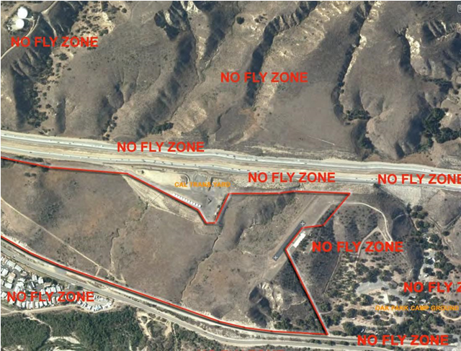
Figure 1. Fly/No-Fly map for all aircraft

  - Fixed-Wing Powered Aircraft Flight Zone Map. Figure 2 shows the flight zone and pilot boxes used for fixed-wing powered aircraft.
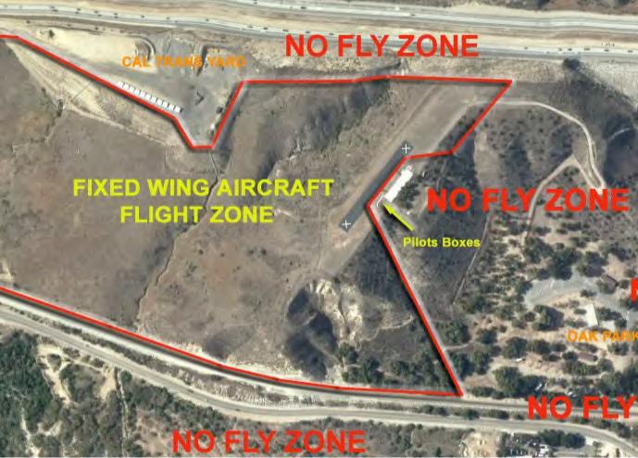

!

.

Figure 2. Fixed-Wing Powered Aircraft Flight Zone

- Powered Fixed Wing Aircraft.

2.1 All aircraft shall fly in the area designated for this type of aircraft as shown in figure 2.
2.2 No more than 5 aircraft are allowed in the air at the same time.
  - Maximum dry take-off weight is 25 lbs.

- Powered Fixed Wing Aircraft with Large Displacement Engines

This section contains the additional and special provisions for aircraft with large displacement engines. The definition of an aircraft with a large displacement engine is a fixed wing aircraft with an engine exceeding 1.20 cubic inches (20cc) two stroke, 1.80 cubic inches (30cc) four stroke, or equivalent electric motor. A multi-engine aircraft with a combined displacement exceeding these limits is also defined as an aircraft with a large displacement engine.

3.1 Pilot Proficiency Program.

3.1.1 A pilot with less than two (2) aircraft with large displacement engines must perform a demonstration flight with a Board Member/designee present at the pilot area and a designated spotter at the northern boundary. The pilot will be required to demonstrate proficiency in take offs and landings along with demonstrating the ability to maintain the aircraft in the permitted boundaries at all times. The flight will require a minimum of two (2) take offs and landings (or touch and goes) each from both South to North and North to South. Downwind landings are at the discretion of the pilot. The proficiency flight may be continued to another day if wind conditions become unsafe or other problem prevents completion of the flight. No other aircraft will be permitted to fly during this check out flight. The Board Member/designee will be in communication with the spotter via walkie-talkie or cell phone during these flights.
3.1.2 Upon satisfactory completion of the demonstration flight the Board Member/designee will issue a permit to the pilot for that aircraft. The pilot's name and plane description will be added to the large displacement aircraft flight approval log that will be posted at the field. Only a Board Member/designee can add pilots to the lists (after satisfactory completion of the demonstration flight). Once a pilot has completed the demonstration flight of two (2) different large displacement aircraft, a Board member/designee will add the pilots name to the large displacement fixed wing log, allowing the pilot to fly large displacement fixed wing aircraft without further demonstration flights.
3.1.3 It is the responsibility of each pilot to make arrangements with a Board Member/designee for the proficiency demonstration flights.
3.1.4 The Board, by a majority vote, may designate any member for the purpose of conduction the proficiency demonstration flight.
3.1.5 Pilots intending to certify for large displacement engine fixed wing aircraft must have approval from any Board Member/designee prior to being flown. The Board Member/designee will issue a permit to operate large displacement engine fixed wing aircraft. The Board Member may decline to issue a permit if he believes either the aircraft cannot be flown in a safe manner and/or the pilot cannot fly the aircraft in a safe manner under the guidelines included in these rules.
3.1.6 All members who wish to fly large displacement engine fixed wing aircraft must have their aircraft inspected by a Board Member/designee prior to being flown for the first time.
3.1.7 No guests will be permitted to fly large displacement engine fixed wing aircraft (unless qualified as defined by the rules in this section).
3.1.8 The privilege to fly large displacement engine fixed wing aircraft maybe revoked at any time for failure to comply with any flight safety rules.
3.1.9 A log sheet with the pilots name and aircraft description will be kept near the frequency board, indicating the pilot’s authorization to fly and will serve as the permit.

3.2 Flight Operations.
3.2.1 No more than two (2) aircraft with large displacement engines may be aloft at the same time.
3.2.2 All pilots must fly within the permitted boundaries for fixed wing aircraft as shown in Figure 2.

- Gliders

4.1 Glider pilots must fly from one of the designated pilot stations if powered fixed wing aircraft are currently flying. If no power fixed wing aircraft are flying pilots may stand at the far southern end of the field as shown in Figure 3.

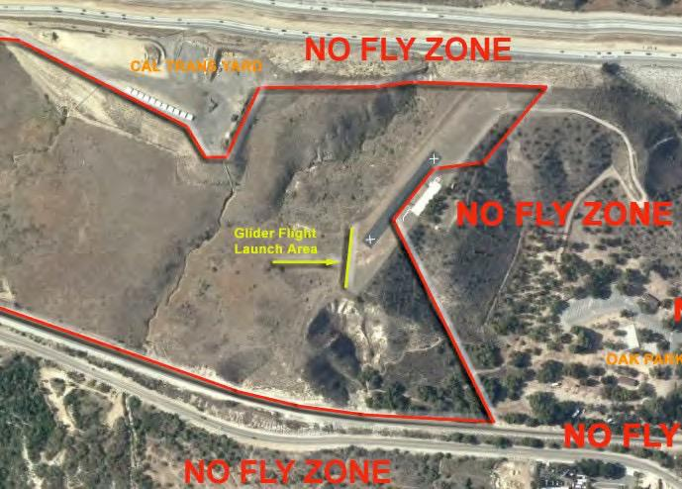

!

Figure 3. Permitted Glider Flight Pilot Area

4.2 Gliders may be flown south of the center of the runway when helicopters are hovering north of he cent of the runway. Pilots must coordinate their flying patterns before their flying begins.

- Helicopters

5.1 During normal flight operation helicopter pilots may fly from the designated pilot area south of the pit area as shown on Figure 4. If a single helicopter pilot is flying, he may fly from any of the pilot boxes.

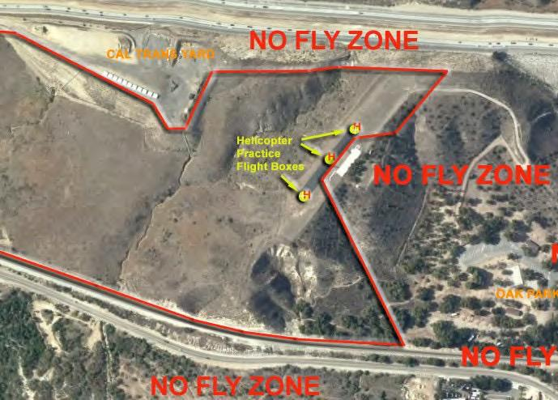

!

Figure 4. Helicopter Flight Pilot Areas

5.2 Hover practice may be performed in the designated area at the north end of the runway. The area is restricted to a 20 foot radius around the “no-fly X”. Altitude is limited to 25 feet. No sustained forward flight is allowed in this area.
5.3 Hover practice may also be performed in the designated area in the center of the runway. The area is restricted to a 20 foot radius around the runway center circle. Altitude is limited to 25 feet. No sustained forward flight is allowed in this area.
5.4 During hover practice the pilot must stay clear of the access road and pit area by a distance of no less than 50 feet.
5.5 No more than 3 helicopters may be flown simultaneously.
5.6 Pilots may air taxi down the runway towards the designated pilot area. Altitude is to be limited to 25 feet. Pilots must follow the runway centerline or fly further west of the centerline. Pilots should proceed directly down the runway until clear of the pit area before undertaking normal flight operations.
6. Multirotor Aircraft.

6.1 Definitions / Limitations
6.1.1 Multirotor aircraft is defined as a vehicle with more than two rotors.
6.1.2 All multirotor aircraft shall fly in the area designated in Figure 4.
6.1.3 No more than 3 multirotor aircraft are allowed in the air at the same time.
6.1.4 Maximum take-off weight is 25 lbs. A multirotor exceeding the weight limit
requires special approval from the Board, which will be of limited use, such as for a special event which will be under the control of the Contest Director or Safety Officer or Board designated individual.
6.1.5 Multirotor aircraft with GPS shall be initialized in one of three launch boxes.
6.1.6 All multirotor aircraft shall have visible orientation devices (lights).
6.1.7 Multi rotor aircraft weighing less than .55 lbs. are exempt from the test requirement.
6.1.8 All multirotor operations must also comply with AMA Requirements.

6.2 Pilot Proficiency Program.

6.2.1 The Safety Officer or the Board (by majority vote) may designate any member for the purpose of conduction the Multirotor Proficiency test.
6.2.2 Pilot must demonstrate knowledge of his multirotor aircraft by completing the Multirotor Proficiency Test, which includes knowledge and flying of the multirotor aircraft.
6.2.3 Upon satisfactory completion of the Proficiency Test the Board Member/designee will issue a permit to the pilot. The pilot's name and plane description will be added to the aircraft flight approval log that will be posted at the field.

Enforcement of Rules

The following is an excerpt from the Club’s Bylaws:

“ARTICLE VIII FLIGHT SAFETY RULES SECTION I GOVERNING RULES

Flight operations at the Simi Valley Flyers site are governed by the document entitled “Simi Valley Flyers Flight Safety Rules”. In addition to rules mandated in

the flight safety rules, all applicable rules of the Academy of Model Aeronautics must be observed.

SECTION II INSURANCE COVERAGE

Members are cautioned that violation of these rules may invalidate your

AMA

insurance coverage.

SECTION III MEMBER RESPONSIBILITY

Any member who observes a violation of any of these rules must notify the

Safety or a member of the Board.

SECTION IV SAFETY OFFICER

Any member who disregards any safety related request by the Safety Officer or the safety officer’s designee is subject to immediate suspension. Any member who willfully disregards a rule that could cause injury or damage to any person or property is subject to immediate suspension by any member of the Board of Directors. The Safety Officer or the Safety

Officer’s designee may impose a temporary rule will remain in effect until the next regular membership meeting.”
Safety Grievance

Form

This form may be used to report a safety rule violation to the Simi Valley Flyers, Board of Directors. Additional pages may be attached as required to explain the violation or circumstances.

Name of member who violated safety rule:

Date and time of the violation:

 | Date |  | Time
 | Description of the Violation:

Safety Rule violated:

Complainant:
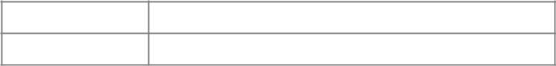
Name

Signature
Location of Complainant when safety violation observed:

Witness to the Safety Rule Violation:
Name

Signature
Location of Witness when safety violation observed:

Other persons present or other relevant information:


